<https://www.virtuallyboring.com/microsoft-wmi-invalid-class-error-0x80041010/>

Microsoft WMI – Invalid Class Error [0x80041010]



You can receive error **0x80041010**from multiple applications that call WMI. For my example it was received in SCCM while patches were being applied.

[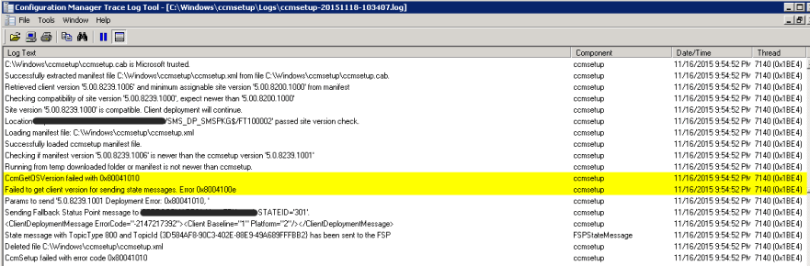](https://www.virtuallyboring.com/microsoft-wmi-invalid-class-error-0x80041010/wmi-configuration-manager-trace-log-error/#main)

No matter where you got the error the underlying issue is probably with WMI. Here is how to check!

**Confirm WMI is Broken:**

Launch the WMI MMC snapin by **Start** -> **Run** -> then enter **WMIMGMT.MSC**

Right click **WMI Control (Local)** and click **Properties**

[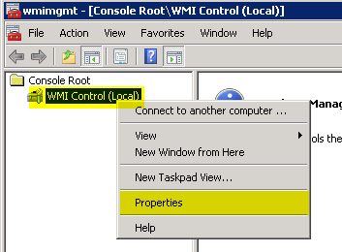](https://www.virtuallyboring.com/microsoft-wmi-invalid-class-error-0x80041010/wmi-1-wmimgmt-msc/#main)

If WMI is working properly then it will show that Good Properties. If you see**Invalid class** then your WMI is not working correctly.

[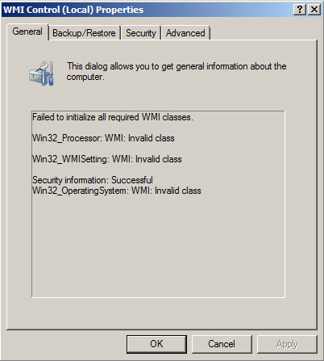](https://www.virtuallyboring.com/microsoft-wmi-invalid-class-error-0x80041010/wmi-2-bad-wmi/#main)

Bad

[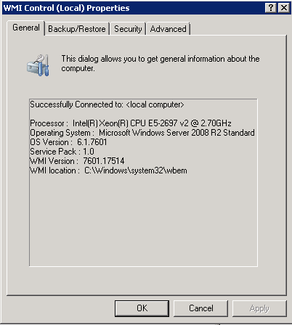](https://www.virtuallyboring.com/microsoft-wmi-invalid-class-error-0x80041010/wmi-2-1-good-wmi/#main)

Good

**Troubleshooting:**

The first step is to download the [Microsoft WMIDiag Tool](https://www.microsoft.com/en-us/download/details.aspx?id=7684). It will analyze WMI and give you a report with any issues it finds.

When you run the downloaded .EXE it will ask you where to extract the files. Once extracted right click the **WMIDiag VBScript** and click **Open with Command Prompt**

[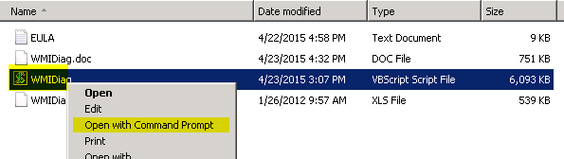](https://www.virtuallyboring.com/microsoft-wmi-invalid-class-error-0x80041010/wmi-3-wmidiag-tool/#main)

Here is what the script looks like while it runs:

[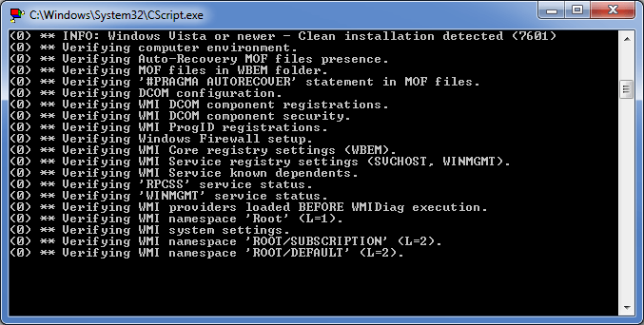](https://www.virtuallyboring.com/microsoft-wmi-invalid-class-error-0x80041010/wmidiag-script-running/#main)

Once complete you will get a text file of the results. Here you should be able to narrow down the cause of your WMI issue. In my case there are issues with .MOF registrations.

[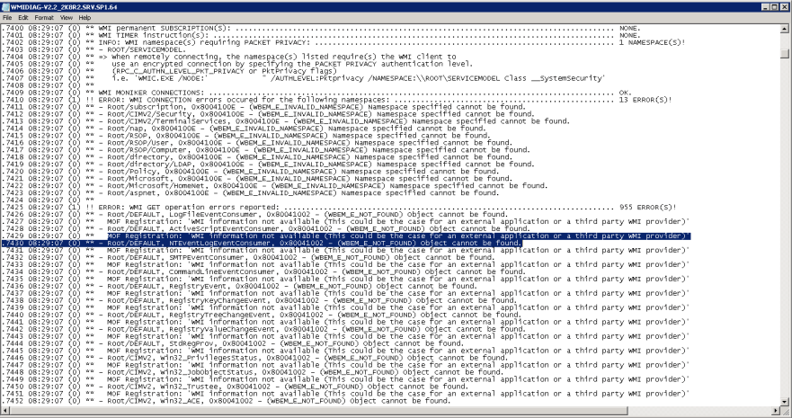](https://www.virtuallyboring.com/microsoft-wmi-invalid-class-error-0x80041010/wmi-4-wmidiag-results/#main)

**Resolve MOF Registration Errors:**

To resolve MOF Registration errors the following commands need to be ran from an elevated command prompt. It will reregister all .MOF files with WMI.

**CD C:\Windows\System32\WBEM**

**dir /b *.mof *.mfl | findstr /v /i uninstall > moflist.txt & for /F %s in (moflist.txt) do mofcomp %s**

Here is what the command looks like while it runs:

[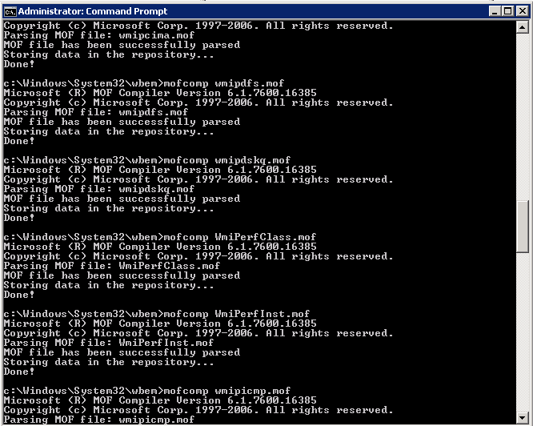](https://www.virtuallyboring.com/microsoft-wmi-invalid-class-error-0x80041010/wmi-5-mof-registration/#main)

Once finished check **WMIMGMT.MSC** to see if it is populating the Properties correctly.

[](https://www.virtuallyboring.com/microsoft-wmi-invalid-class-error-0x80041010/wmi-2-1-good-wmi/#main)